**Altimetrik Interview Question**

**Collection Framework Hierarchy**

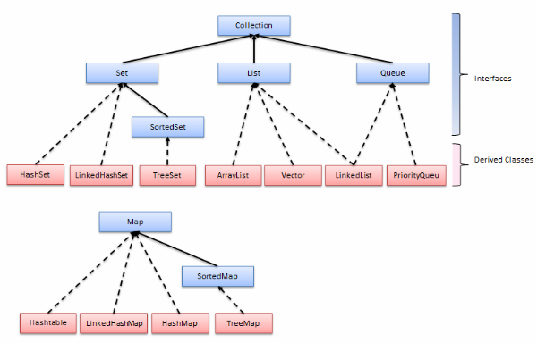

Given a class Person, how will you implement TreeSet with it?

Explanation of equals method of Comparator interface.

Which all Listeners you have worked with?

* IRetryAnalyzer, IAnnotationTransformer
* ITest
* IReporter

**Why do we need surefire plugin? Can we run testing.xml with maven without surefire plugin?**

**Implicit wait and explicit wait. Why shouldn’t we mix both?**

<http://stackoverflow.com/questions/29474296/clarification-on-the-cause-of-mixing-implicit-and-explicit-waits-of-selenium-doc>

**Product backlog and sprint backlog**

**Cucumber**:

* Feature file, scenario, scenario outline, parallel execution
* Difference between cucumber and jbehave
* Command for running cucumber test from cmd

**Exception throwing overridden method**

Subclass’s overridden method can’t throw broader exception. However it can throw same or narrowed exception than parent’s overriding method.

**Up casting and down casting in java**

Up-casting is casting to a supertype, while downcasting is casting to a subtype. Supercasting is always allowed, but subcasting involves a type check and can throw a ClassCastException.

Example: A parent class P has method m1() and child class C has one overridden method m1() and other normal method m2(). Then:

P p1 = new C();

P1.m1() is allowed.

P1.m2() is not allowed. ((C)p1).m2() need to be done.

C c1 = (C) P;

**Taking screenshot in selenium (Thorough explanation of each terms)**

<http://stackoverflow.com/questions/21877839/can-any-one-explain-screenshot-in-selenium>

**Iterating over Map* (see entryset)**

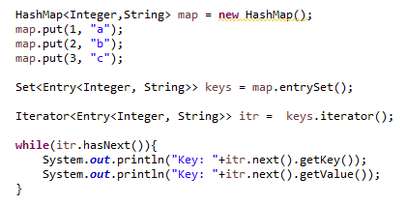

**Regex**

**Print something without main method.**

Using static block.

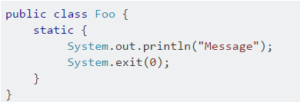

**Working**: Because the static initializer block is executed when the class is first loaded, we can print out “Hello World” without writing a main method. The execution is stopped using “System.exit()” command. So, we prevent “main method not found” error.

***Note****: It was possible till java 6 to use System.out.println(); without main(). From java 7 onwards, it is not possible to do it with static block. It will still ask for main method in main class.*

**RemoteWebdriver**

<http://www.myyesm.com/what-is-remotewebdriver/> 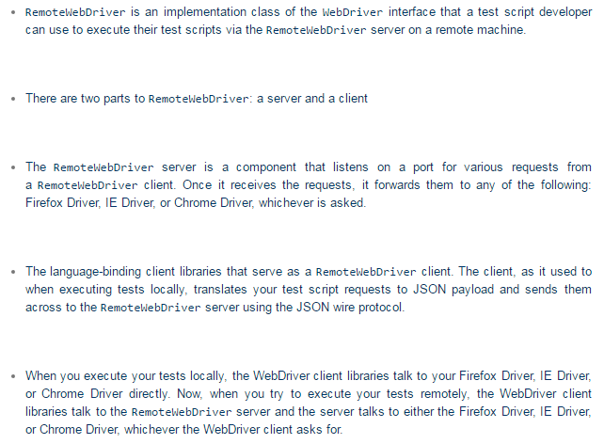

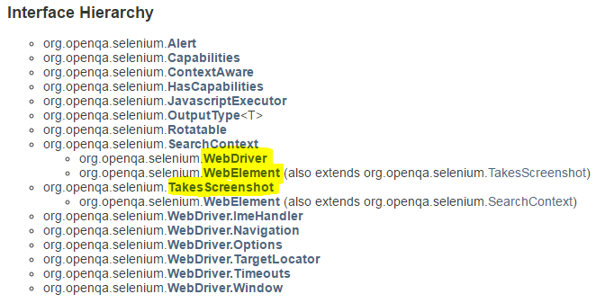

**Versions: Cucumber, Maven, TestNG, Selenium**

Maven: 3.3.9

TestNG: 6.8 (Latest is 6.9)

Selenium: 2.53

Cucumber: 1.2.4 (Latest is 1.2.5)

**HashMap vs HashTable**

<http://javahungry.blogspot.com/2014/03/hashmap-vs-hashtable-difference-with-example-java-interview-questions.html>

<http://javahungry.blogspot.com/2013/08/hashing-how-hash-map-works-in-java-or.html>

**Jenkins**

**TestPlan**